Bac and Christos’ Poster 2: ECR 2020 - C-04814: MR Urography - The Radiographer’s Perspective

This study aims to analyze the Magnetic Resonance Urography (MRU) techniques and to portray the Radiographer's role in this demanding MRI examination.

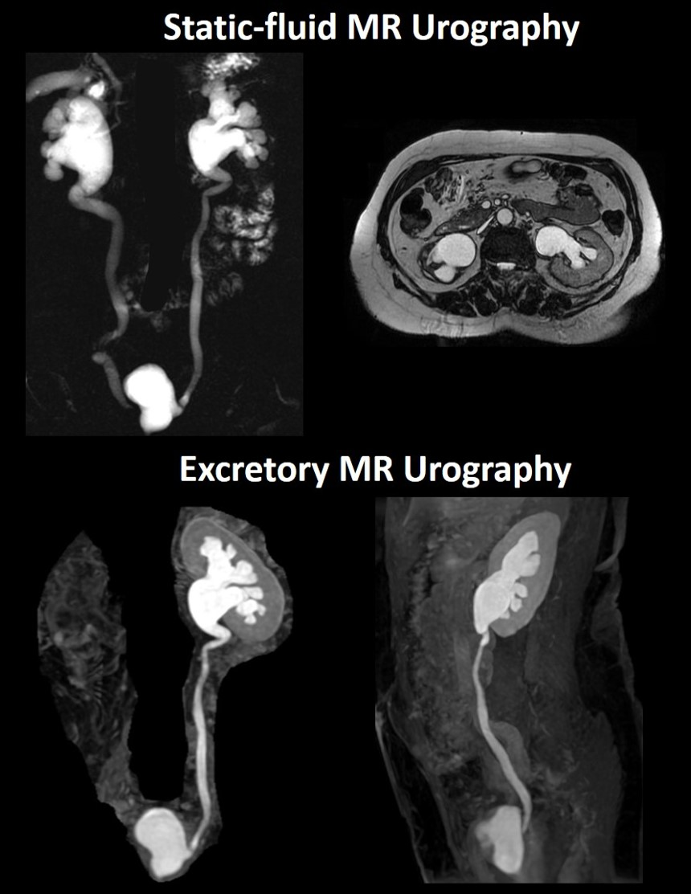
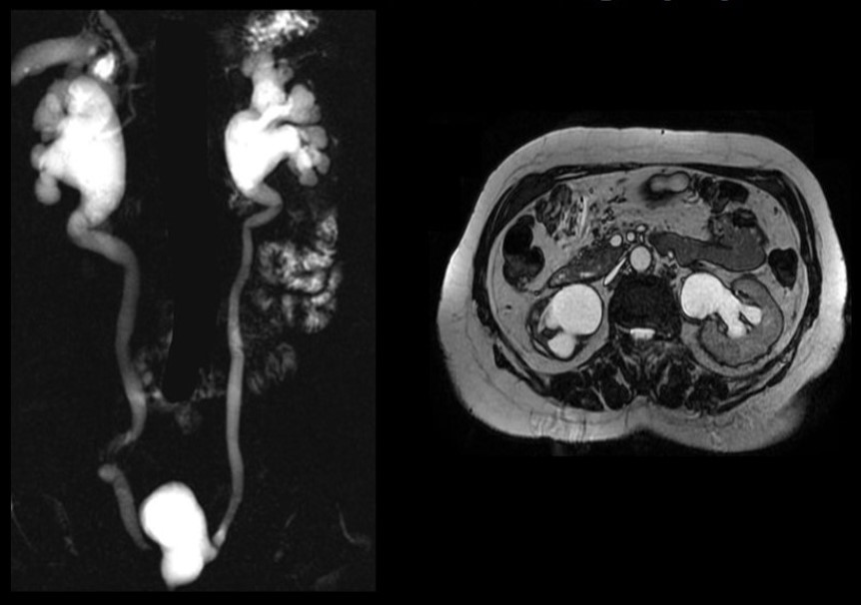
Fig. 1: Top row shows static-fluid MR Urography, based on heavily T2-weighted images, while the bottom row demonstrates excretory MR Urography, based on T1-weighted acquisitions.

References: Limassol/CY

Fig. 2: Static-fluid MR Urography. Heavily T2-weighted thick-slab with long echo time (left) and balanced steady-state gradient echo/FIESTA acquisition show hydronephrosis with dilation of the pelvicalyceal system.

References: Limassol/CY

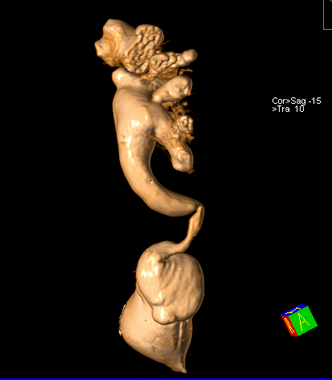
Fig. 3: Figure shows a volume rendering (VR) image of a 3D T2-weighted SPACE acquisition. Volume rendering is a type of data visualization technique which creates a three dimensional representation of data.

References: Bac Nguyen

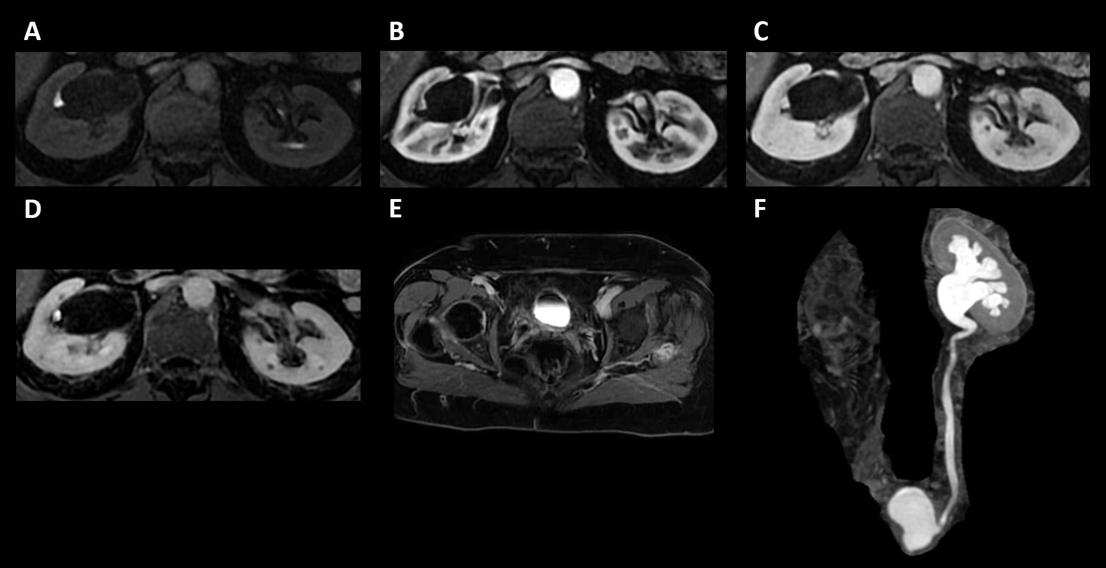

Fig. 4: Dynamic contrast-enhanced excretory MR Urography in native (A), corticomedullary (B), nephrographic (C) and excretory phases (D, E, F). For excretory MR Urography, a 3D fat-suppressed T1-w gradient-echo sequence is used. Fat suppression enhances the conspicuity of the ureters and is recommended.

References: Limassol/CY

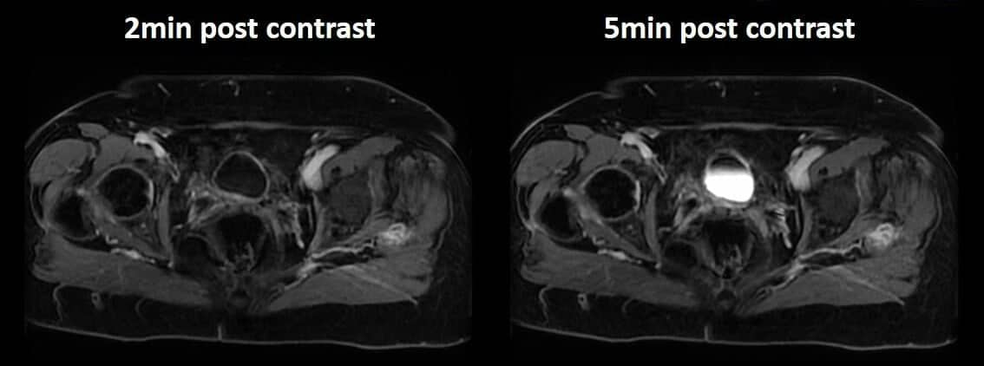
Fig. 5: Figure highlights the importance of immediate urinary bladder imaging post-contrast (approximately 2 minutes post-injection) to demonstrate bladder wall enhancement before the arrival of contrast agent via the ureters.

References: - Limassol/CY

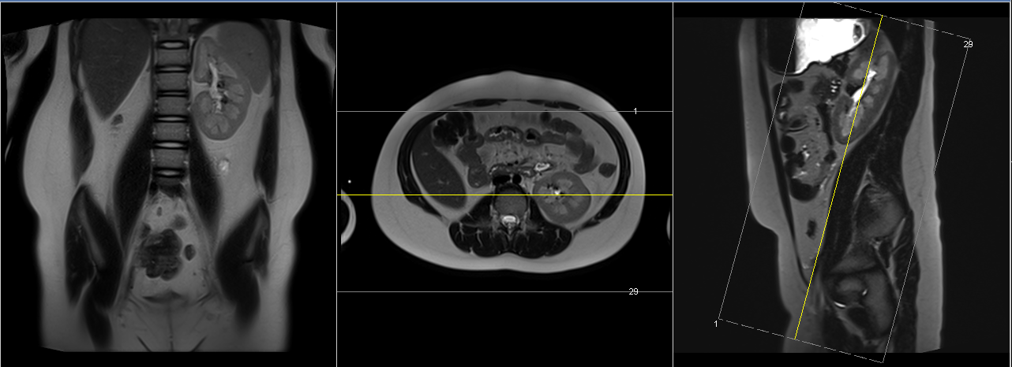
Fig. 6: MRU Protocol for the Evaluation of the Urinary System

Plan the coronal slices on the axial and sagittal planes. Position the slab parallel to the kidneys in the axial plane and parallel to the ureters in the sagittal plane as shown. Slices and FOV should cover the entire urinary system, including kidneys, ureters and bladder.

References: Bac Nguyen

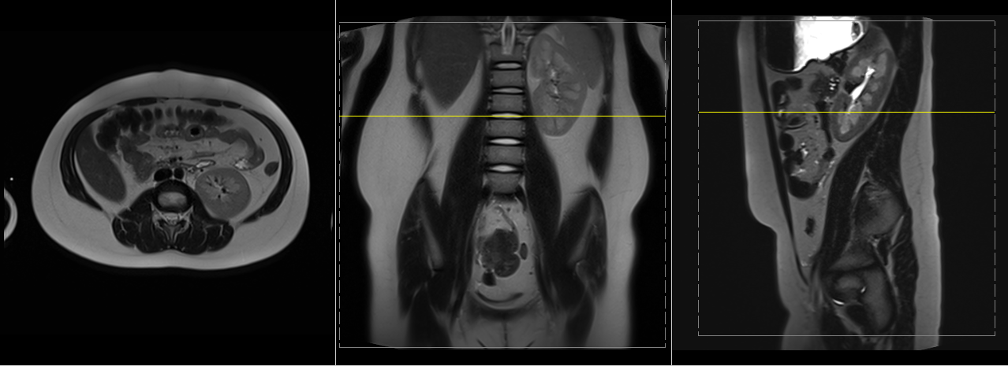
Fig. 7: MRU Protocol for the Evaluation of the Urinary System

Fig. 7: Plan the axial slices on the coronal and sagittal planes. Position the slab parallel to the kidneys as shown. Slices should cover the entire urinary system, including kidneys, ureters and bladder. Axial acquisitions are 2-part due to the length of the area of interest.

References: Bac Nguyen
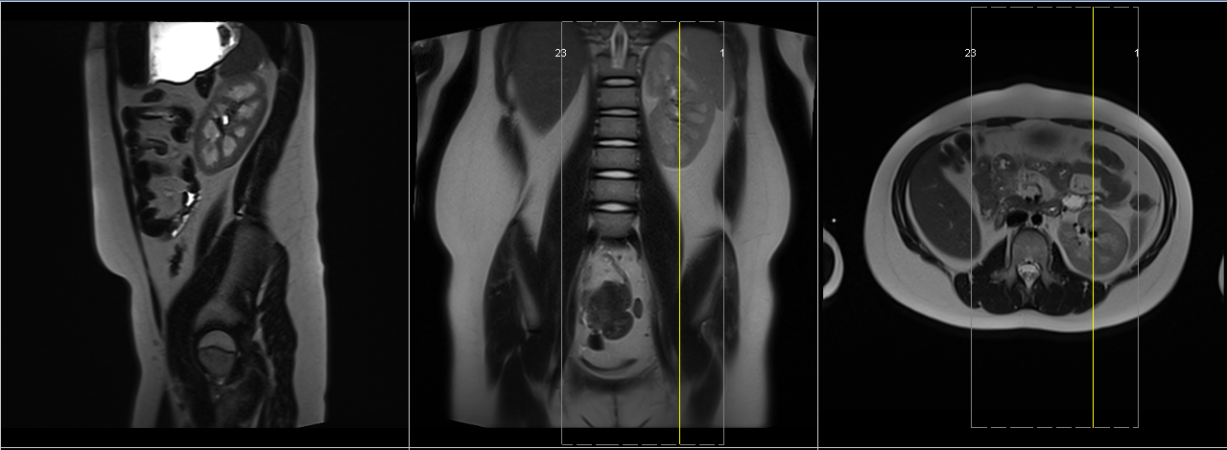

Fig. 8: MRU Protocol for the Evaluation of the Urinary System

Fig. 8: Plan the sagittal slices on the coronal and axial planes. Position the slab parallel to the kidneys as shown. Slices and FOV should cover the entire urinary system, including kidneys, ureters and bladder. For Sagittal acquisitions, plan for each kidney separately.

References: Bac Nguyen

